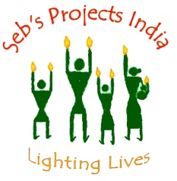

SEBASTIAN HUNTER MEMORIAL SCHOOL
AND COMMUNITY DEVELOPMENT PROJECT TRUST
No. 6, 10th East Cross Road, Gandhi Nagar, Vellore, 632 006, Tamil Nadu, India.
Telephone: 0091 416 2243165, Mobile: 0091 9843042695
Email: emma.koshi@gmail.com, Website: www.sebsprojectsindia.org

HEALTH STATUS IN JAWAHDI
In this health document we have tried to summarize the SEBS health programme and recommendations for the way forward.
Background to health SEBS health programme
Sulochana and Asodha, the tribal health workers have completed their BSS Nursing (2 year course) in THI Sittilingi. They belong to the local community and have been working in the villages of Jawadhi malai since September 2017.
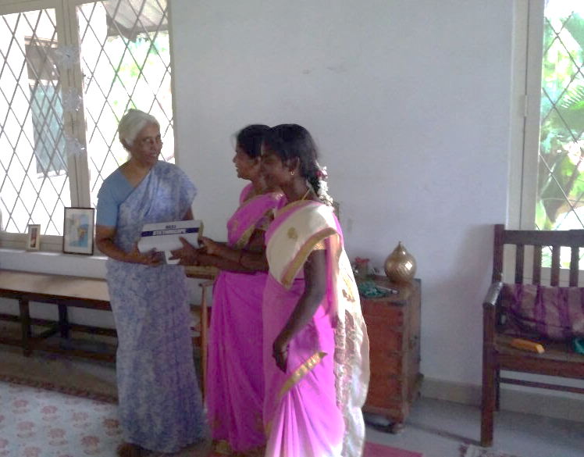
The health programme has been set up through the Seb’s primary schools and balwadi teachers. It involves partnering with ICDS to run two fully functioning Balwadi's. The two public health nurses are working in 8 villages in Palampattu panchayat. The villages were chosen based on the proximity to Sulochana and Ashoda’s village and also discussions with the local panchayat. The health programme networks with CHAD mobile clinic service and with CHAD hospital and Odugathur PHC for emergency and referral services. The health work is being planned and supervised by Eunice and Dominic.
Dr. Sara Bhattacharji had a meeting and conducted some training for Sulochana and Ashodha at the end of last year.
- The work done by health workers
- They maintain registers of the families. They have obtained basic demographic and health data (see table at end of document).
They have:
- Enumerated the families in these 8 villages
- Identified the chronic morbidity and psychological problems/mental handicap
- Identified pregnant and lactating mothers
- Recent deaths and their causes
- They visit each village about once a month
- They provide symptomatic medicines for ailments
- They talk to individual families and also do some health education
- They facilitate the CHAD mobile visits- by having village meetings before the mobile visits. They work with the mobile teams taking blood pressure, drawing blood and helping with the mobile clinic activities.
- Facilitate referral

- Health priorities identified by the health team
The perceived health issues in these villages are:
- Specific health conditions (a) Suicide and mental health problems (b) alcoholism (c) Hypertension (d) Cardiac problems ( e) Anaemia (f) Undernutrition (g) Maternal and child care
- Lack of access to referral service: in case of emergency, many of the villages cannot be accessed by ambulance and motorised transport due to poor road access.
- Health seeking behaviour: Lack of birth spacing and reluctance to take up family planning measures; home delivery; going to traditional practitioners before seeking help of the allopathic treatment
- Lack of knowledge about common health problems
- Social determinants: lack of safe water, free availability of pesticides due to cotton farming which is triggering suicides, food habits (traditional millets are not being used in diet), sanitation, free availability of alcohol

Recommendations and impressions of the work of the health workers by Dr. Annand Zachariah of CMC
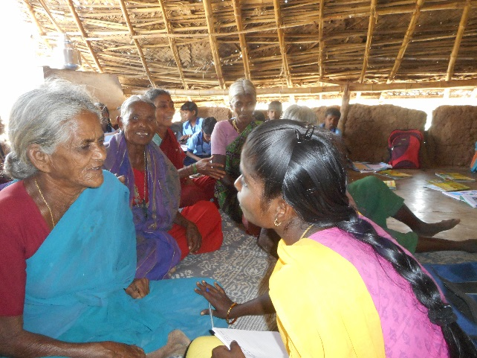
The health workers are enthusiastic. They have a certain amount of knowledge and skills which they have effectively used. They are knowledgeable about the problems of the villages, individual family’s health problems, recent deaths and the difficulties faced in providing health care.
The health workers had developed the confidence of the village communities. They are conducting basic primary care along with the CHAD mobile vans. They have obtained basic health data from these villages and have a working knowledge about the local health problems. They also have established a working relationship with CHAD.
They need more help with the method of recording data, analysis and assessment of the health situation, identifying and developing strategies for addressing public problems and also with conducting mass health education. Strengthening of the linkage with CHAD would be helpful for better sharing of information, coordination of work and as a training resource.
- Overall suggestions:
- Strengthen the capacity of the health workers
- Periodic review of their work by a person with public health expertise
- Review of the methods of recording health data
- Health education strategies
- Identifying health problems in the community and developing strategies to address these
- Steps in community organisation towards collective ownership, engagement and greater awareness regarding health issues
- Enhance linkage with CHAD
- Continue and expand health work through the SEBS schools and balwadi’s
- To prepare a more detailed analysis of the health situation in these 8 villages. A public health and health delivery strategy can be developed based on this analysis.

- Immediate steps may include:
  - Preparation of a report on the health work that has been done so far. To include:
- Village wise record of chronic disease morbidity, causes of the recent deaths, pregnant mothers on antenatal care, under 5 children status regarding nutrition and immunisation
- Priority health problems and present concerns regarding the health situation
- Possible health strategies for the SEBS programme
  - A review with Dr. Sara B including a visit to the villages to gain an understanding of the actual work by the health workers.
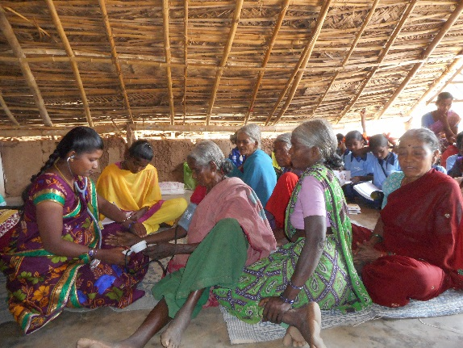
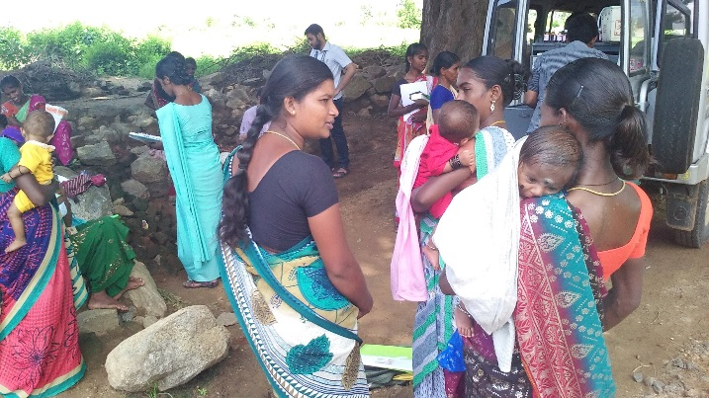
  - A presentation and discussion with CHAD.

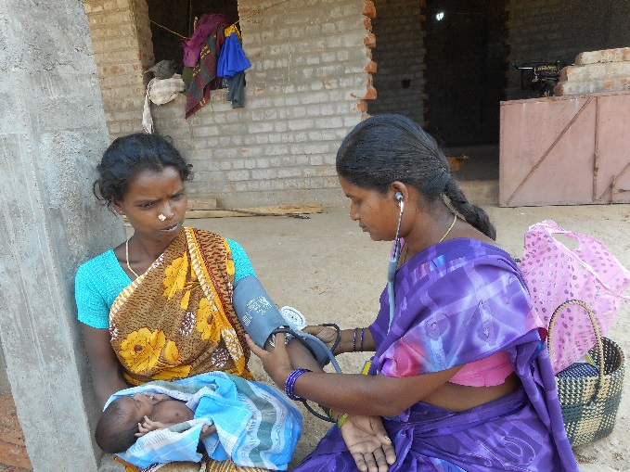
Overall comments
SEBS as an organization focused on school education which is entering the field of health based on the perceived local need. The two health workers are slowly gaining confidence and establishing primary health care along with the CHAD mobile services. Their presence appears to be making a palpable difference to the villages where are working. A carefully planned and incremental approach of developing the health work in these 8 villages based on a situation analysis involving the local community and other partners may be feasible strategy forward.
The villages in the Jawadhi hills are so remote and there is hardly any mortorble roads. The people have very little access compounded by lack of Awareness to reach out to a health center. The infant and mother mortality rates are very high in comparison with the data available for Vellore District.
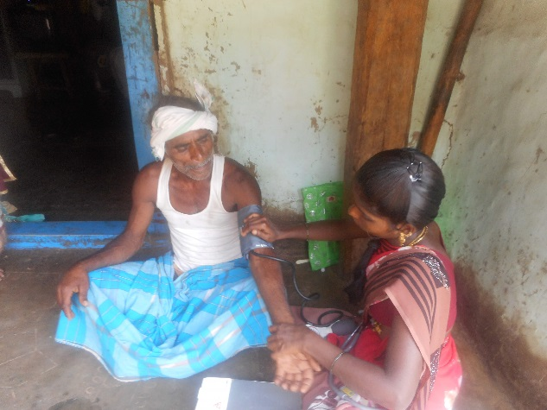
There are some unavoidable and emergency situation of childbirth happening in in the village particularly when medical support is not available. In these situations our health workers educate them on hygienic delivery practices. They make sure that every pregnant women are ready with a bag of necessary equipment’s. The health workers advise women on hygiene and nutrition, and convince them to visit the nearest health centers for further health check-ups. As a result these remote villages have now started to have childbirth in hospital
Our partnership with the CMC hospital offers Jawadhi people with concession for chronic illness. The relation between the health workers and the hospital staff helps to share information about patients for follow-ups.
Sulochana a health workers shared this incident where she was instrumental in saving a young mother’s life. The CMC mobile clinic visits the villages and it is our health workers who mobilizes the community for the clinic. Saroja is a pregnant women, her blood samples were taken during the visit and tested in the hospital. Her result shows a complication in her pregn ancy. The doctors from the hospital called Sulochana through phone and explained the need for Saroja to visit the hospital. Sulochana rushed to Saroja’s village and explained the emergency situation to get admitted in hospital. Saroja was treated in the hospital and delivered the baby. Both the mother and child are in good health.
Our health workers visits our schools and organizes awareness program for our school children on health and hygiene practices. They also educate Adolescents girls in the community and educate them on adolescent health and values.
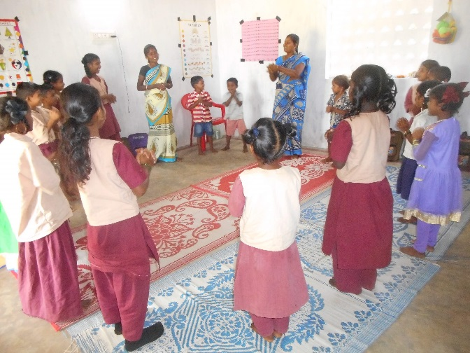
Overall our health workers are knowledgeable about the problems in the villages and individual family’s health problem. They are good in documenting about the all the datas realated to health. They are very enthusiastic a bout their work and they have effectively used their knowledge and skills.
Balwadi/Health program
Balwadi teachers/ health workers provide micro nutrient supplements, noon meals for children and iron/vitamin tablets for pregnant and nursing mothers. New born children are registered with our balwadi centers for specific care and growth monitoring. Regular height and weight checkup, follow up immunization routine are closely monitored by health workers.
Water and Sanitation
Water and sanitation continues to be the hardest challenge. It is difficult to chlorinate the open wells and there is no possible ways to chlorinate the overhead tanks, because the motor pumps are not functional due to low electricity. Our children are taught to strain and boil the water for drinking and the same method is practiced in our school premises. Now the children teach their families to adopt safe drinking practices and bring clean drinking water in bottles to school. Though the water condition is bad, it is so convincing that our effort in educating our school children have made a big change in the attitude of the young generation.
Toilets are still an unknown term for the villages in Jawadhi hills. Our partnership with the Government education Department is going to make it a reality this coming year. They have come forward to build school classrooms, kitchen and toilets facilities. We hope this will be a great step to introduce the importance of using toilets and teach the children and the community of hygiene and usage of toilets.
As part of the health program, we partnered with Restless Development and conducted a workshop on important issues such as Sanitation and usage of toilets, hand washing techniques, menstrual health and Child Sexual Abuse.

---------------------

